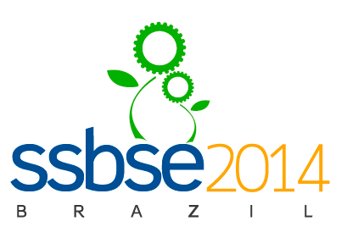
REGISTRATION
FORM

GENERAL INSTRUCTIONS
- Fill in and send this Registration Form to ssbse2014@uece.br.
- In case you select Bank Transfer as payment option, attach the bank transfer order/receipt.
- Registration fees and payment information are described in www.ssbse.org.
- In case you wish to pay by Bank Transfer and are not sure about the exact fee you should pay, please
contact the conference chair (ssbse2014@uece.br) to have the correct information before making
your payment.

PERSONAL INFORMATION
Title: | Full Name:
Name you want on your badge:
Affiliation:
Address:
City: |  | Country:
E-mail: |  | Phone Number:

REGISTRATION INFORMATION
Participant Profile: | ( ) Professional  ( ) Student | Registration Package: | ( ) All Inclusive  ( ) Conference Only

IN CASE OF “ALL INCLUSIVE”
Room Occupancy: | ( ) Single Room  ( ) Double Room  ( ) Triple Room | # of Accompanying People: | ( ) None  ( ) 1 person  ( ) 2 persons

PERSONAL INFORMATION ON ACCOMPANYING PEOPLE
Name: | Name:
Relationship: | Relationship:
Age (in years): | Age (in years):

PAYMENT INFORMATION
Payment Option: | ( ) Bank Transfer  ( ) Credit Card

